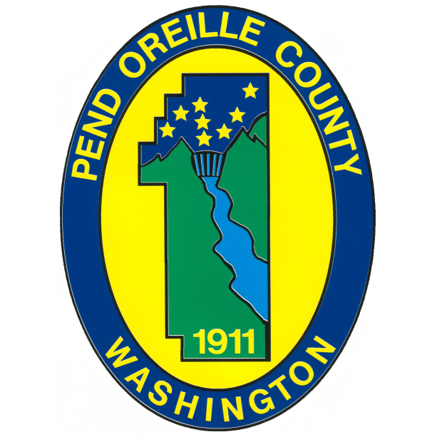

Clinical Director

Supplemental Essay Question

In order to get a better sense of your writing skills and additional insights into your experience, please answer the following question. Limit your response to no more than a single page and upload your answer as part of your online application by August 3, 2025 (first review, open until filled).

- Please tell us why you are interested in this position and why it is a good time in your career to come to Pend Oreille County as their next Clinical Director. How does your experience align with the requirements of this position?

